EPIC — Technical Architecture
A walkthrough of the EPIC (Enterprise Pipeline for Infrastructure & Cloud) platform, following the architecture flow: User Experience → Source of Truth → CI/CD Control Plane → Multi-Cloud Workloads, with Centralized Quality & Security underpinning every run.
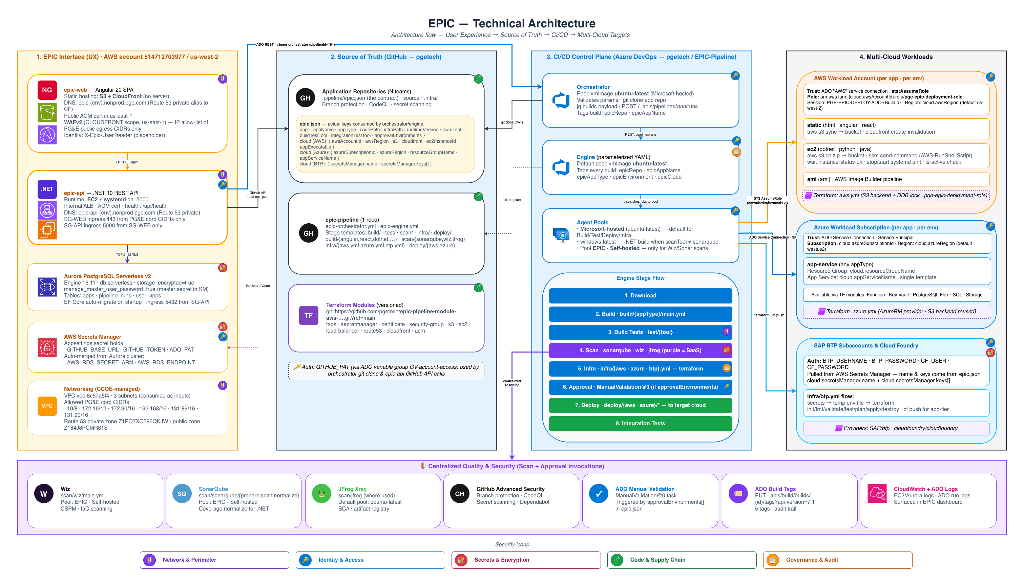
EPIC Technical Architecture

Overview
EPIC is an internal developer platform (IDP) that gives every application team a single, standardized CI/CD pipeline. Teams do not build, maintain, or debug their own pipelines. They publish a contract file — .pipeline/epic.json — that declares what to build and where to deploy, and EPIC owns everything else: build, test, scan, infrastructure provisioning, approval, deploy, and integration testing across AWS, Azure, and SAP BTP.
The architecture diagram reads left-to-right as a flow, with a cross-cutting band along the bottom:
- EPIC Interface (UX) — the developer-facing surface, hosted in AWS account 514712703977.
- Source of Truth (GitHub) — the contract and the pipeline code itself.
- CI/CD Control Plane (Azure DevOps) — the orchestrator, engine, agent pools, and stage flow.
- Multi-Cloud Workloads — the AWS, Azure, and BTP targets where applications actually run.
- Centralized Quality & Security — scanning, approval, tagging, and observability that every run passes through.
The five colored chips along the very bottom — Network & Perimeter, Identity & Access, Secrets & Encryption, Code & Supply Chain, and Governance & Audit — are the security domains that each component in the diagram is mapped against.

1. EPIC Interface (UX) — AWS account 514712703977 / us-west-2
This is the layer developers and operators actually touch. It lives in a single AWS account and is composed of four building blocks plus its supporting network.

epic-web — Angular 20 SPA
The dashboard for managing applications and pipeline runs.
- Hosting: static hosting on S3 + CloudFront (no server).
- DNS: epic{-env}.ncnprod.pge.com (Route 53 private alias to CloudFront).
- TLS: public ACM certificate, us-east-1.
- WAF: v2 (CLOUDFRONT scope, us-east-1) — IP allow-list plus PG&E public-egress CIDRs only.
- Identity: today the SPA sends an X-Epic-User header as a placeholder until MSAL/JWT auth is wired in.

epic-api — .NET 10 REST API
The brains of the UX layer; it reconciles GitHub and Azure DevOps state and serves it to the SPA.
- Runtime: EC2, deployed behind an internal ALB, listening on :5000.
- ALB: internal ALB with a /health health check.
- DNS: epic-api{-env}.ncnprod.pge.com (Route 53 private).
- Ingress: SG-WEB → 5000, plus PG&E corp CIDRs; the SG-API ingress on 5000 comes from SG-WEB.

Aurora PostgreSQL Serverless v2
The API’s datastore.
- Engine 16.11, serverless, storage_encrypted = true.
- manage_master_user_password = true (master secret held in Secrets Manager).
- Tables: apps, pipeline_runs, user_apps.
- EF Core auto-migrates on startup, connecting on 5432 from SG-API.

AWS Secrets Manager
The secret store for the UX layer.
- Holds application settings: GITHUB_BASE_URL, GITHUB_TOKEN, ADO_PAT.
- Auto-merged from the Aurora cluster: AWS_RDS_SECRET_ARN, AWS_RDS_ENDPOINT — so the API assembles its connection string at runtime rather than storing a static DB password.

Networking (CCOE-managed)
The shared VPC that the UX layer runs inside.
- VPC vpc-8c57a5f4, 3 subnets consumed as inputs.
- Allowed PG&E corp CIDRs: 10/8, 172.16/12, 172.30/16, 192.168/16, 131.89/16, 131.90/16.
- Route 53 private zone Z1PO7XO596QKJW and public zone Z184J8PGMR81S.

2. Source of Truth (GitHub — pgetech org)
Everything EPIC executes originates in GitHub. There is no hidden state: the contract, the pipeline, and the infrastructure modules are all versioned here.

Application Repositories (N teams)
Each application team owns a repo containing the EPIC contract.
- .pipeline/epic.json is the contract — it is the only file teams must author.
- Protected by branch protection, CodeQL, and secret scanning.
The orchestrator actually consumes these keys from epic.json:
- app section: appName, appType, codePath, infraPath, runtimeVersion, scanTool, buildTestTool, integrationTestTool, approvalEnvironments, appServiceName, appExecutable.
- cloud section (AWS): awsAccountId, awsRegion, s3, cloudfront, ec2InstanceId.
- cloud section (Azure): azureSubscriptionId, azureRegion, resourceGroupName.
- cloud section (BTP): secretsManager.name, secretsManager.keys[].

epic-pipeline (1 repo)
The pipeline framework itself.
- epic-orchestrator.yml and epic-engine.yml are the two top-level pipelines.
- Stage templates: build/, test/, scan/, infra/, deploy/.
- Build dispatch: build/{angular,react,dotnet,…} · scan: scan/{sonarqube,wiz,jfrog} · infra: infra/{aws.yml,azure.yml,btp.yml} · deploy: deploy/{aws,azure}.

Terraform Modules (versioned)
Reusable infrastructure building blocks.
- Source: https://github.com/pgetech/epic-pipeline-module-aws-….git?ref=main.
- Tags/modules include: secretsmanager, certificate, security-group, s3, ec2, load-balancer, route53, cloudfront, acm.

Auth
GITHUB_PAT (sourced via the ADO variable group GV-account-access) is used both for the orchestrator’s git clone and for the epic-api GitHub API calls.

3. CI/CD Control Plane (Azure DevOps — pgetech / EPIC-Pipeline)
This is where pipelines actually run. The control plane is split into a lightweight orchestrator (the entry point) and a heavyweight engine (the execution plane), backed by agent pools.

Orchestrator (epic-orchestrator.yml)
The thin, auditable entry point. It contains no Terraform or build logic.
- Pool: vmImage: ubuntu-latest (Microsoft-hosted).
- Validates the runtime parameters (repo, branch, config, environment).
- git clones the app repo (via GITHUB_PAT) to read .pipeline/epic.json.
- Builds the engine payload with jq — normalizing booleans, detecting the cloud provider, resolving whether infrastructure exists, and resolving the approval gate.
- Triggers the engine with POST /_apis/pipelines/194/runs (the engine’s pipeline ID) and returns a clean, clickable run URL.
- Tags its own build with epicRepo and epicAppName.
Cloud detection logic (resolved in the orchestrator): appType == "btp" → BTP; else cloud.awsAccountId → AWS; else cloud.azureSubscriptionId → Azure; default AWS.
Infra resolution: if the infraPath folder is absent and the app is not BTP, terraformAction is forced to none; otherwise it honors the requested apply/destroy.

Engine (epic-engine.yml, parameterized YAML)
The control plane that wires up the stages with correct dependency ordering.
- Default pool: vmImage: ubuntu-latest.
- Tags every build with epicRepo, epicAppName, epicAppType, epicEnvironment, and epicCloud — these tags are what the epic-api and dashboard later read back to populate the Technology / Cloud / Environment columns.

Agent Pools
- Microsoft-hosted (ubuntu-latest) — the default for Build / Test / Deploy / Infra.
- windows-latest — used for .NET builds when scanTool is SonarQube.
- Pool EPIC - Self-hosted — reserved for Wiz / SonarQube scans.

Engine Stage Flow
The engine assembles up to eight stages, each conditionally included based on the payload. Dependency ordering is enforced so that scan/infra/approval/deploy fan in correctly.
- Download — pulls the app source.
- Build — build/{appType}/main.yml.
- Build Tests — test/{tool} (only when a buildTestTool is set).
- Scan — sonarqube · wiz · jfrog (purple = SaaS/centralized scanning).
- Infra — infra/{aws · azure · btp}.yml — Terraform.
- Approval — ManualValidation@0 (only when the target env is in approvalEnvironments).
- Deploy — deploy/{aws · azure}/* — to the target cloud.
- Integration Tests — post-deploy verification.
The Scan stage (and the Approval invocation) reach out to the centralized Quality & Security band at the bottom of the diagram, rather than being self-contained.

4. Multi-Cloud Workloads
This is where the applications actually land. EPIC dispatches to one of three target families, per app, per environment, based on the detected cloud provider. Each target uses a workload-specific identity, never a shared static credential.

AWS Workload Account (per app · per env)
- Trust: the ADO “AWS” service connection assumes sts:AssumeRole.
- Role: arn:aws:iam::{cloud.awsAccountId}:role/pge-epic-deployment-role.
- Session: EPIC-DEPLOY-ADO-{BuildId} · region cloud.awsRegion (default us-west-2).
- Workload patterns:
  - static (html · angular · react) — aws s3 sync → bucket → cloudfront create-invalidation.
  - ec2 (dotnet · python · java) — aws s3 cp zip → bucket → SSM send-command (AWS-RunShellScript), then wait for instance-status-ok / stop/start systemd unit / is-active check.
  - ami — AWS Image Builder pipeline.
- Terraform: aws.yml (S3 backend + DynamoDB lock) runs as pge-epic-deployment-role.

Azure Workload Subscription (per app · per env)
- Trust: the ADO Service Connection / Service Principal.
- Subscription: cloud.azureSubscriptionId · region cloud.azureRegion (default westus2).
- app-service (any appType): Resource Group cloud.resourceGroupName, App Service cloud.appServiceName — single template.
- Available via Terraform modules: Function · Key Vault · PostgreSQL Flex · SQL · Storage.
- Terraform: azure.yml (AzureRM provider · S3 backend reused).

SAP BTP Subaccounts & Cloud Foundry (per app · per env)
- Auth: BTP_USERNAME · BTP_PASSWORD · CF_USER · CF_PASSWORD, pulled from AWS Secrets Manager — the secret name and key list come from epic.json’s cloud.secretsManager.name and cloud.secretsManager.keys[].
- infra/btp.yml flow: secrets → temp env file → terraform init / fmt / validate / test / plan / apply / destroy → cf push for the app tier.
- Providers: SAP/btp · cloudfoundry/cloudfoundry.

5. Centralized Quality & Security (Scan + Approval invocations)
Rather than each app re-implementing quality gates, EPIC routes every run through a shared set of services. These are invoked from the engine’s Scan and Approval stages.
- Wiz — scan/wiz/main.yml; Pool EPIC - Self-hosted; CSPM · IaC scanning.
- SonarQube — scan/sonarqube/{prepare,scan,normalize}; Pool EPIC - Self-hosted; coverage normalization for .NET.
- JFrog Xray — scan/jfrog (where used); default pool ubuntu-latest; SCA · artifact registry.
- GitHub Advanced Security — branch protection · CodeQL · secret scanning · Dependabot.
- ADO Manual Validation — ManualValidation@0 task, triggered by the approvalEnvironments[] array in epic.json.
- ADO Build Tags — PUT _apis/build/builds/{id}/tags?api-version=7.1; the 5 EPIC tags form the audit trail and the data source for the dashboard.
- CloudWatch + ADO Logs — EC2/Aurora logs and ADO run logs, surfaced back in the EPIC dashboard.

End-to-End Flow Summary
Putting the layers together, a single deployment travels through the platform like this:
- A developer (or the epic-web dashboard via epic-api) triggers the orchestrator in Azure DevOps.
- The orchestrator clones the app repo from GitHub, reads .pipeline/epic.json, detects the cloud provider, resolves the infra and approval gates, and builds a payload.
- The orchestrator POSTs that payload to the engine (pipeline 194) and returns a run URL.
- The engine downloads the source, then conditionally runs Build → Build Tests → Scan → Infra → Approval → Deploy → Integration Tests, tagging the build with epicRepo / epicAppName / epicAppType / epicEnvironment / epicCloud along the way.
- Scans route through the centralized Wiz / SonarQube / JFrog services; approval (when required) goes through ADO Manual Validation.
- Deploy dispatches to the detected cloud workload — AWS (assume-role), Azure (service principal), or BTP (Cloud Foundry) — provisioning infrastructure via the versioned Terraform modules when terraformAction is not none.
- epic-api reads the build tags and ADO run state back, persists them to Aurora, and epic-web surfaces the live status in the dashboard.
The result is one pipeline, one set of guarantees (auth, tagging, networking, scanning, audit), and 100% coverage — with the only per-team variation living in a single declarative epic.json contract.

